**Steps that were followed to initialize GITBASH**

Cd .. // Current Directory

Cd ..

Cd DevOps

Mkdir pavankowshik //creates new file name pavankowshik

Git int

Ls // Show the list of files in Directory

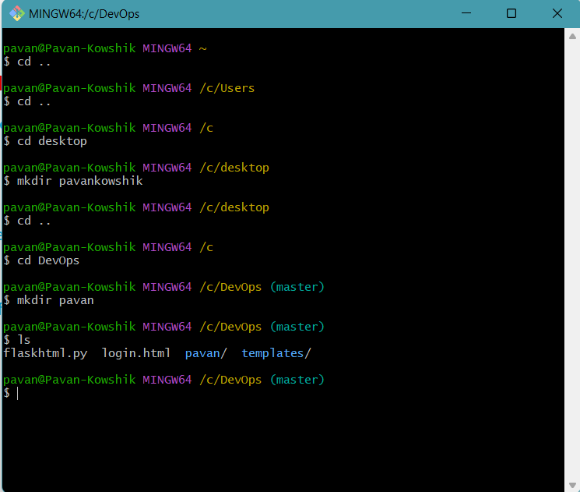

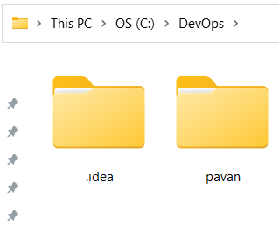

Git init //initializing git in the file path and we can see hidden files in

the file location(some may not see those file due to security

issues or anti virus)

git status //Track the status of the file(any commits done or made are shown)

clear // It clears the page

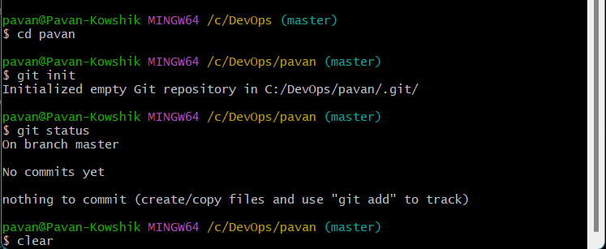

$ touch text.txt //Creates a file name text.txt in the folder(touch is used to create file)

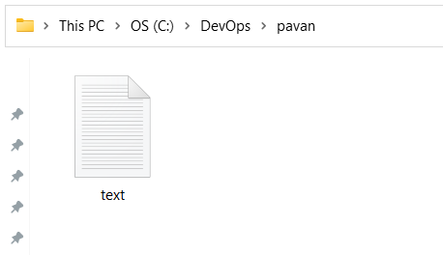

$ git status

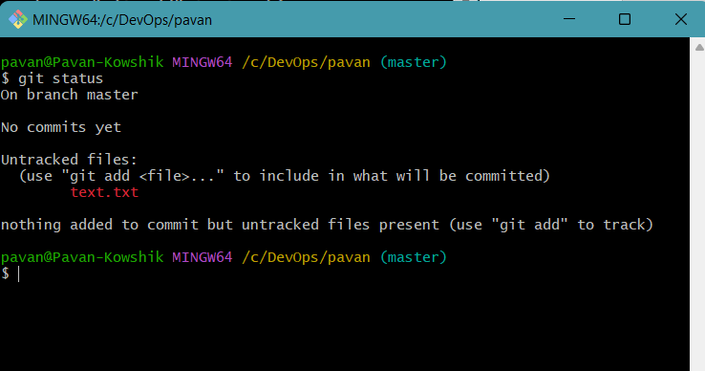

$ git add text.txt //Adding the file

$ git status

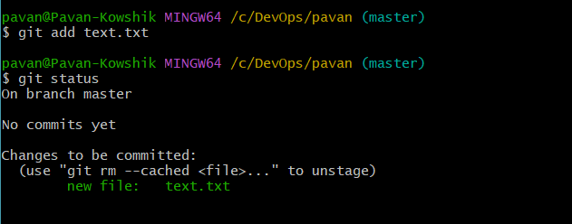

*** Now open text.txt file, add text to the file and save the file.***

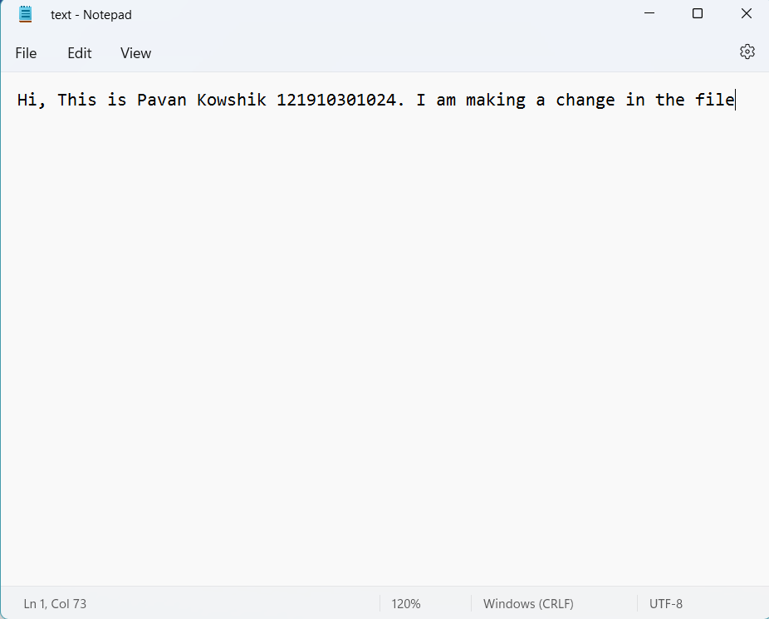

***We need to always add the file after me make any changes to the file.***

$ git add text.txt

$ git status

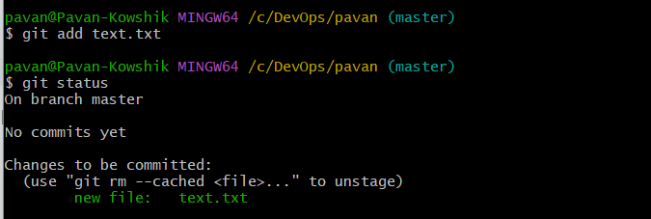

$ git commit -m addingcommit // Adding commit to the file(-m is message)

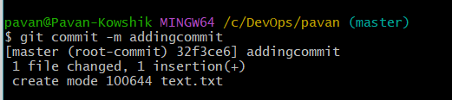

***Now we are going to add the local file to the GITHUB repository ***

$ git remote add origin "https://github.com/pavankowshik2001/test.git"

$ git push -u origin master //Pushing the code to the repository

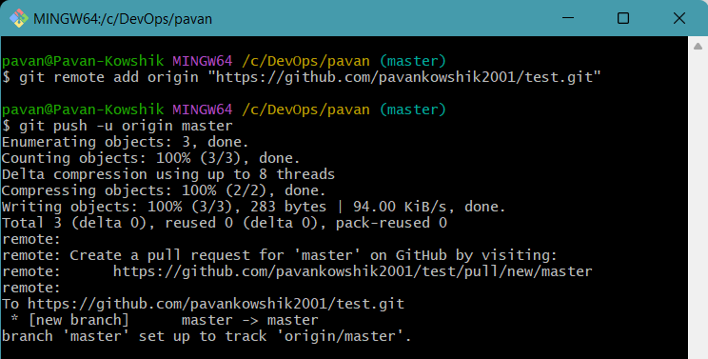

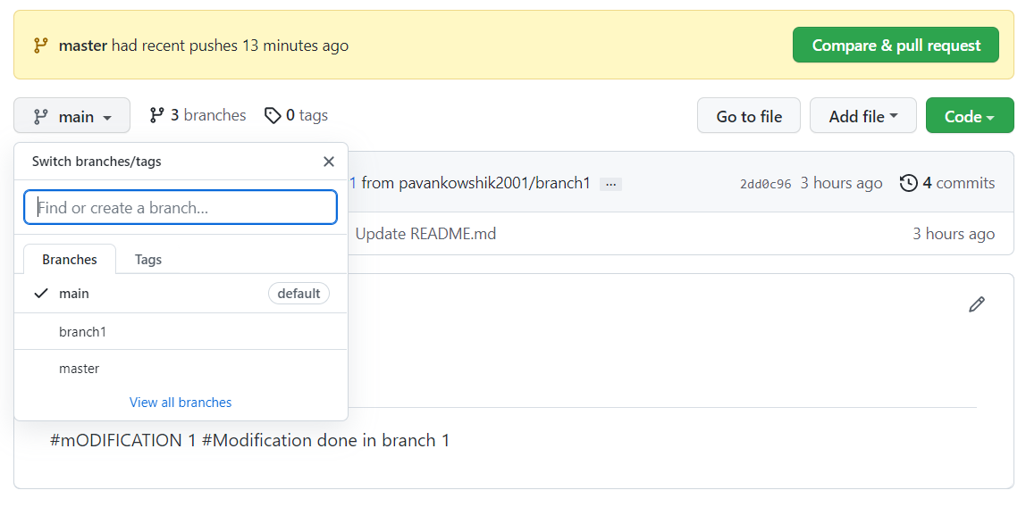

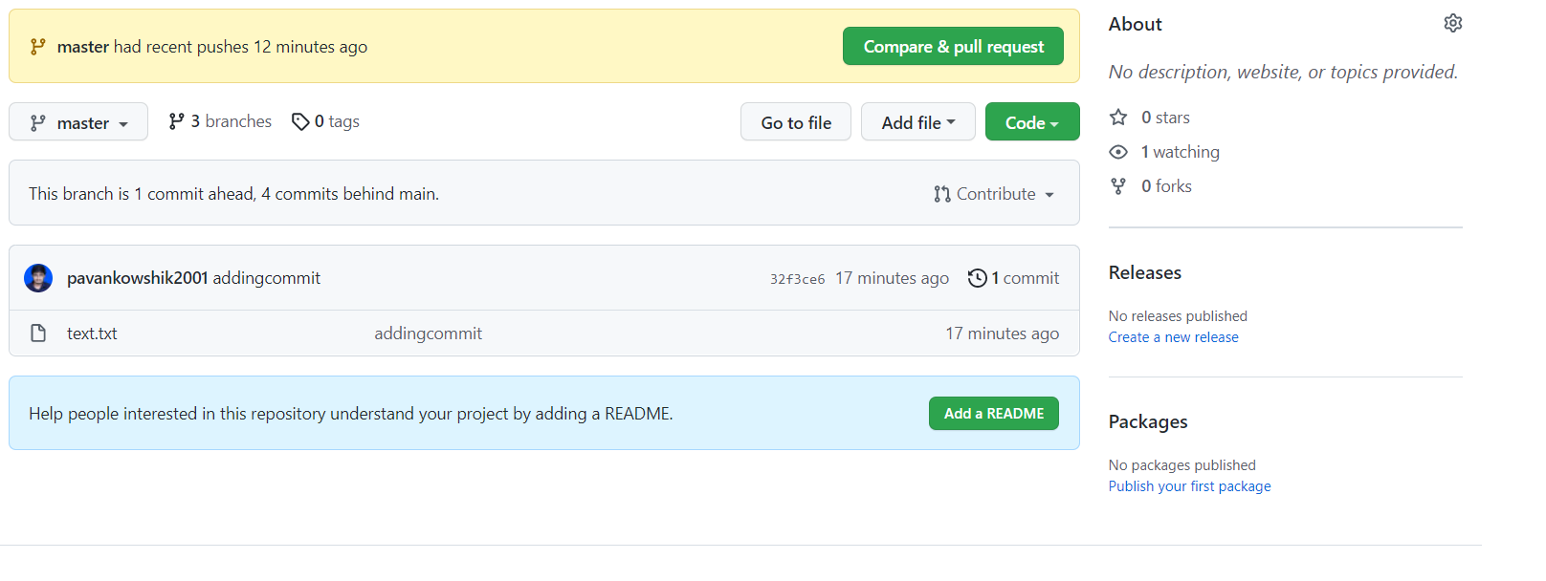

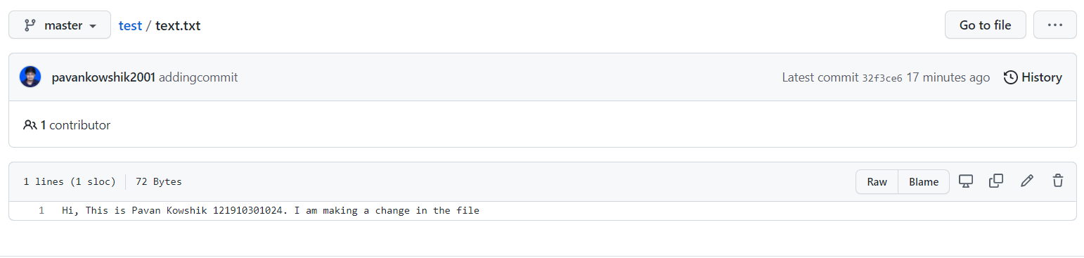

***Creating New Branch***

$ git branch branch2 //Creates new Branch name “branch2”

$ git branch // Shows all the branches

$ git checkout branch2 // Switching from master to branch

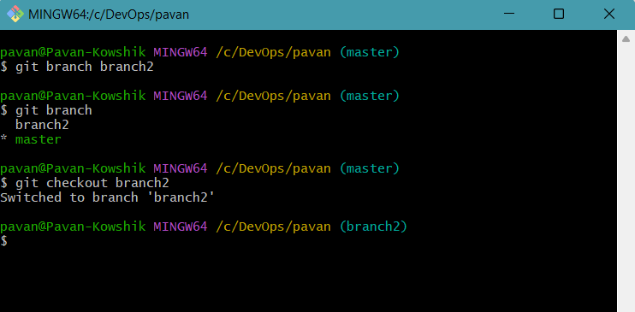

$ git status

$ git add . // Adds all the files(add.)

$ git commit -m commitNumber2 // Add commit to the branch

$ git push origin branch2 // Pushing the local repository to GITHUB

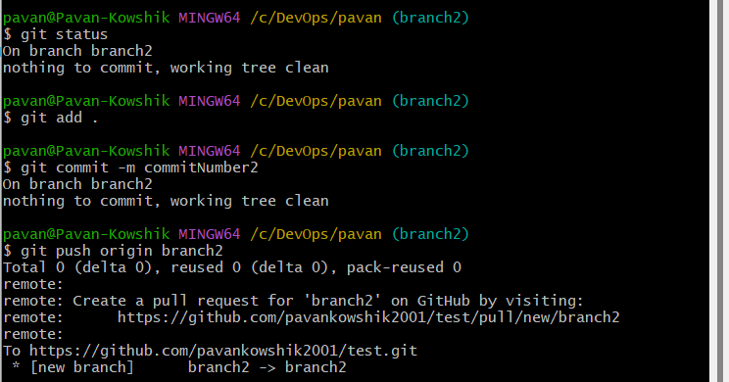

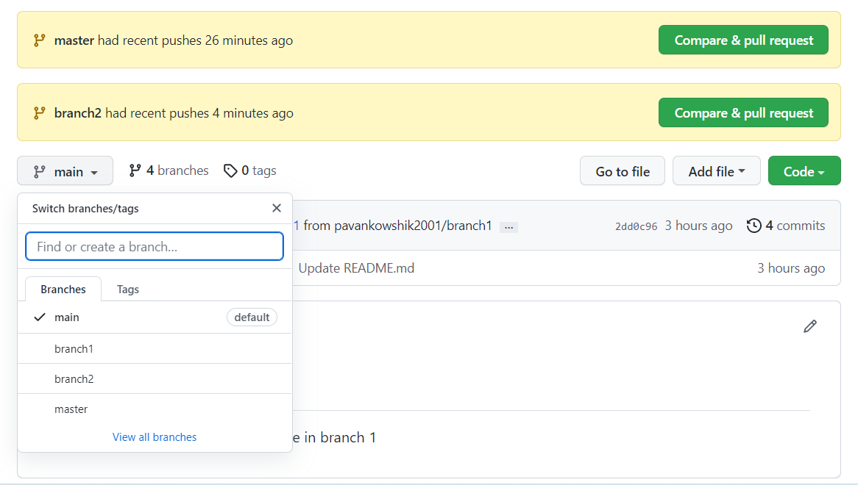

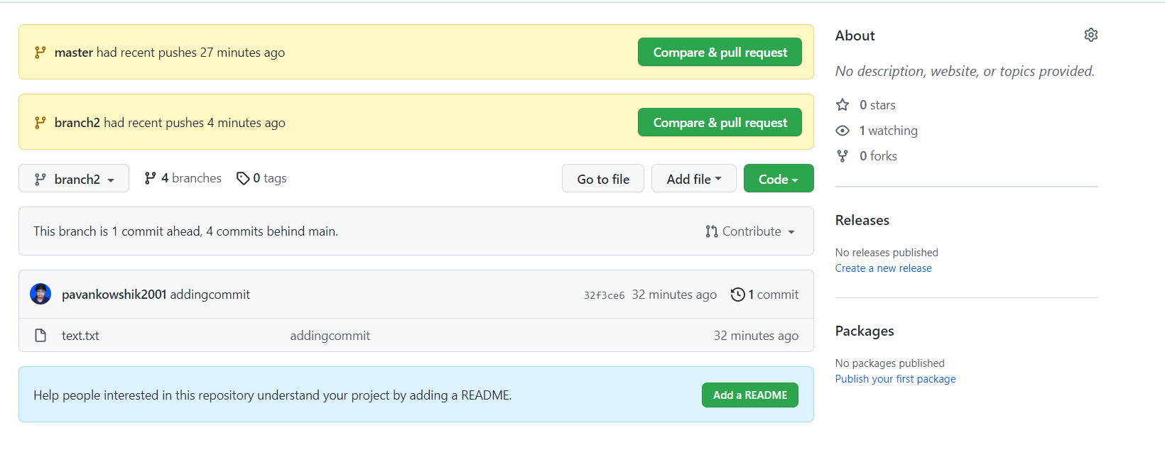

**\*\*\*Don’t want to track the branch\*\*\***

$ touch .gitignore

$ git add .

$ git status

